Ideation Phase
Brainstorm & Idea Prioritization Template

Date | 05 October 2026
Team ID | SWTID-2026-4248
Project Name | LearnMate AI StudyBuddy
Maximum Marks | 4 Marks

Brainstorm & Idea Prioritization Template:
Brainstorming provides a free and open environment that encourages everyone within a team to participate in the creative thinking process that leads to problem solving. Prioritizing volume over value, out-of-the-box ideas are welcome and built upon, and all participants are encouraged to collaborate, helping each other develop a rich amount of creative solutions.
Use this template in your own brainstorming sessions so your team can unleash their imagination and start shaping concepts even if you're not sitting in the same room.
Reference: https://www.mural.co/templates/brainstorm-and-idea-prioritization
Step-1: Team Gathering, Collaboration and Select the Problem Statement
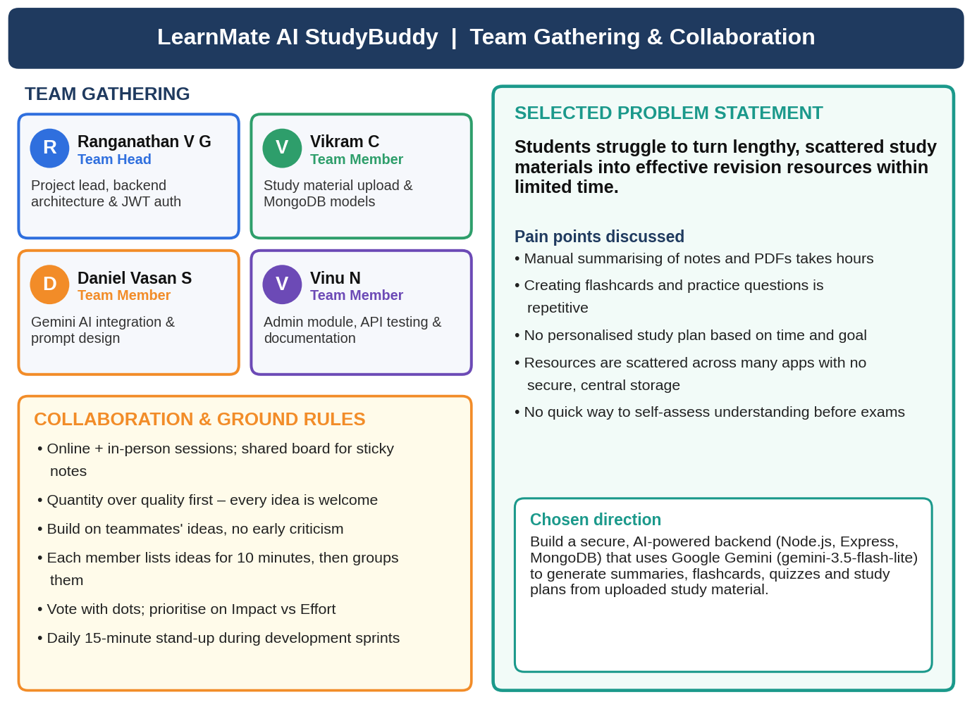
Team LearnMate (Ranganathan V G – Team Head, Vikram C, Daniel Vasan S, Vinu N) gathered, agreed on the ground rules and selected the problem statement: students struggle to convert lengthy, scattered study material into effective revision resources in limited time.

Step-2: Brainstorm, Idea Listing and Grouping
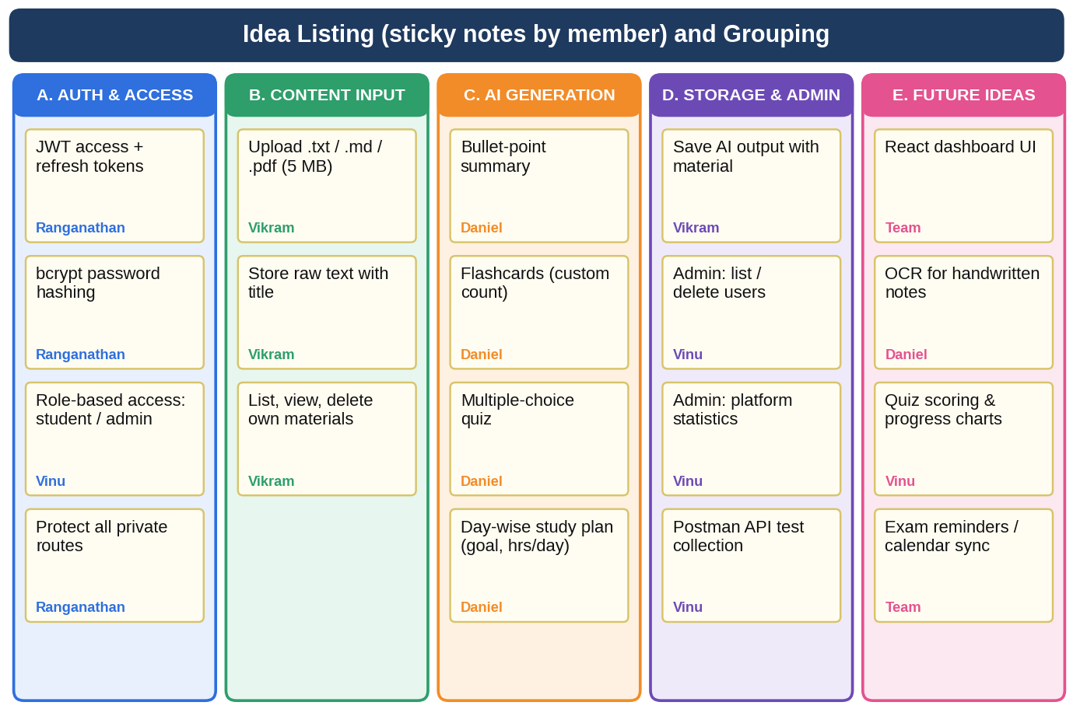
Ideas were listed individually and then grouped into five themes: Auth & Access, Content Input, AI Generation, Storage & Admin, and Future Ideas.

Step-3: Idea Prioritization
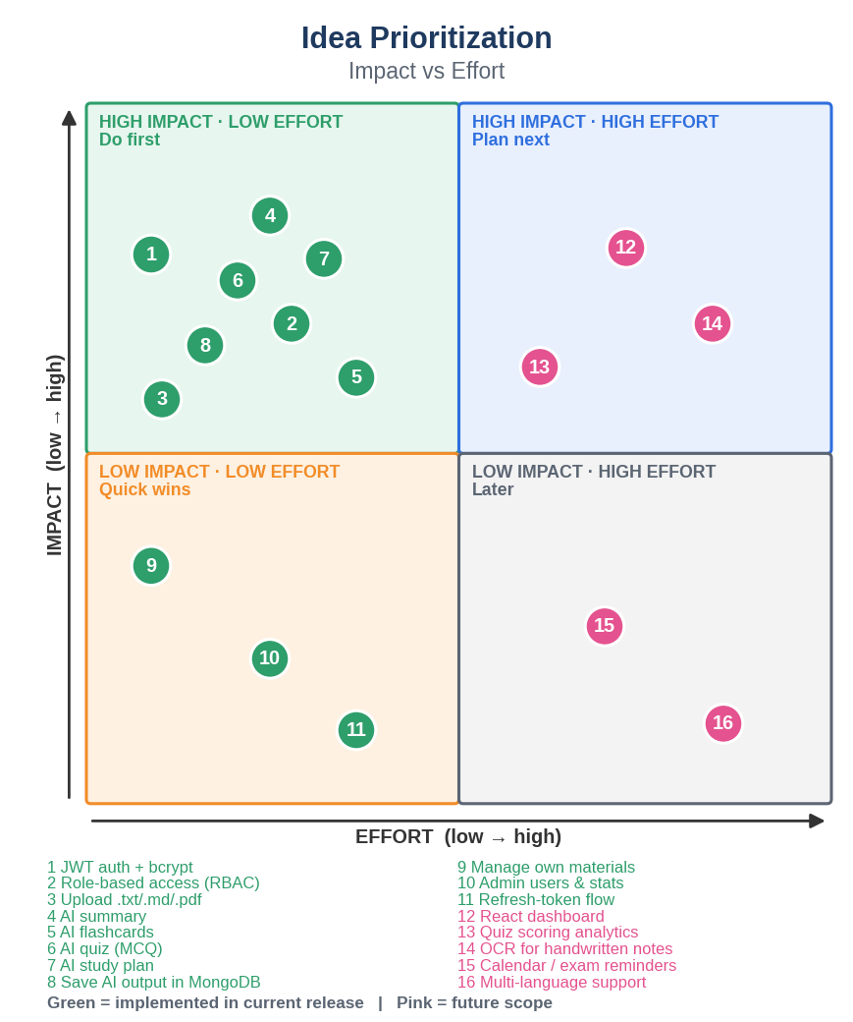
Ideas 1–11 (JWT auth, RBAC, material upload, AI summary, flashcards, quiz, study plan, saved results, material management, admin tools and refresh tokens) were prioritised for the current release. Ideas 12–16 (React dashboard, quiz analytics, OCR, exam reminders, multi-language) are future scope.

